|  |  |
| --- | --- |
| Roll No.: B055 | Name: Arpit Kubadia |
| Class: B.Tech CS B | Module: 3 |
| Assignment:1-10 | Date: 1/12/2018 |
| Grade: | Batch: 3 |

## Assignment 1

**Assignment Question:**



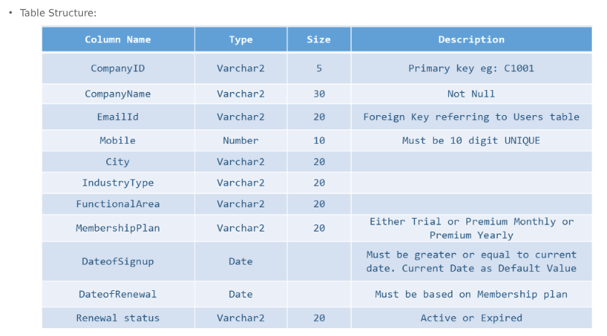

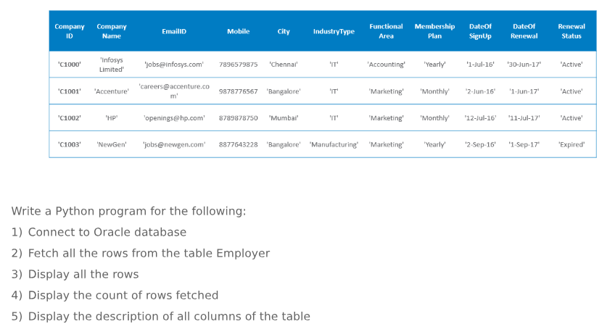

**Code:**

import cx_Oracle

from pprint import pprint

con = cx_Oracle.connect('SYSTEM', ‘sandy’, 'xe')

#print (con.version)

cur = con.cursor()

cur.execute("DROP TABLE Employer")

cur.execute("CREATE TABLE Employer(\

    CompanyID varchar2(5) PRIMARY KEY, \

    CompanyName Varchar2(50) NOT NULL,\

    EmailID Varchar2(30),\

    Mobile Number(10) CHECK (length(Mobile)=10),\

    City Varchar2(15),\

    IndustryType Varchar2(20),\

    FunctionalArea Varchar2(20),\

    MembershipPlan Varchar2(20) CHECK (MembershipPlan IN('Trial','Monthly','Yearly')), \

    DateofSignup Date,\

    DateofRenewal Date,\

    RenewalStatus varchar2(10) CHECK (RenewalStatus IN ('Active','Expired')))")

cur.execute("INSERT INTO Employer (CompanyID,CompanyName,EmailID,Mobile,City,IndustryType,FunctionalArea,MembershipPlan,DateofSignup,DateofRenewal,RenewalStatus) values ('C1000','Infosys Limited','jobs@infosys.com',7896579875,'Chennai','IT', 'Accounting','Yearly',TO_DATE('01/07/2016','DD/MM/YY'),TO_DATE('30/06/2017','DD/MM/YY'),'Active')")

cur.execute("INSERT INTO Employer (CompanyID,CompanyName,EmailID,Mobile,City,IndustryType,FunctionalArea,MembershipPlan,DateofSignup,DateofRenewal,RenewalStatus) values ('C1001','Accenture','careers@accenture.com',9878776567,'Bangalore','IT', 'Marketing','Monthly',TO_DATE('02/06/2016','DD/MM/YY'),TO_DATE('01/07/2017','DD/MM/YY'),'Active')")

cur.execute("INSERT INTO Employer (CompanyID,CompanyName,EmailID,Mobile,City,IndustryType,FunctionalArea,MembershipPlan,DateofSignup,DateofRenewal,RenewalStatus) values ('C1002','HP','openings@hp.com',8789878750,'Mumbai','IT', 'Marketing','Monthly',TO_DATE('12/07/2016','DD/MM/YY'),TO_DATE('11/07/2017','DD/MM/YY'),'Active')")

cur.execute("INSERT INTO Employer (CompanyID,CompanyName,EmailID,Mobile,City,IndustryType,FunctionalArea,MembershipPlan,DateofSignup,DateofRenewal,RenewalStatus) values ('C1003','NewGen','jobs@newgen.com',8877643228,'Bangalore','Manufacturing', 'Marketing','Yearly', TO_DATE('02/09/2016','DD/MM/YY'),TO_DATE('01/09/2017','DD/MM/YY'),'Expired')")

cur.execute("SELECT * FROM Employer")

print("ALL THE ROWS:")

for record in cur:

print(record, "\n")

print("\nCount of rows: ", cur.rowcount)

print("\nDesciption: ", cur.description)

con.close()

**Output:**

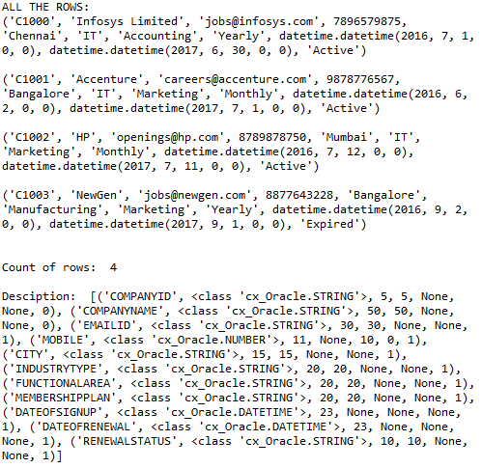

## Assignment 2

**Assignment Question:**

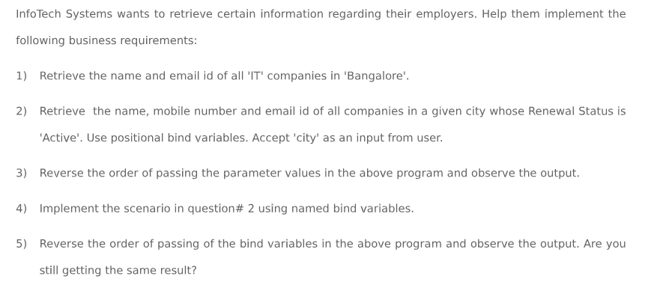

**Code:**

import cx_Oracle

from pprint import pprint

con = cx_Oracle.connect('SYSTEM', ‘sandy’, 'xe')

#print (con.version)

cur = con.cursor()

cur.execute("DROP TABLE Employer")

cur.execute("CREATE TABLE Employer(\

    CompanyID varchar2(5) PRIMARY KEY, \

    CompanyName Varchar2(50) NOT NULL,\

    EmailID Varchar2(30),\

    Mobile Number(10) CHECK (length(Mobile)=10),\

    City Varchar2(15),\

    IndustryType Varchar2(20),\

    FunctionalArea Varchar2(20),\

    MembershipPlan Varchar2(20) CHECK (MembershipPlan IN('Trial','Monthly','Yearly')), \

    DateofSignup Date,\

    DateofRenewal Date,\

    RenewalStatus varchar2(10) CHECK (RenewalStatus IN ('Active','Expired')))")

cur.execute("INSERT INTO Employer (CompanyID,CompanyName,EmailID,Mobile,City,IndustryType,FunctionalArea,MembershipPlan,DateofSignup,DateofRenewal,RenewalStatus) values ('C1000','Infosys Limited','jobs@infosys.com',7896579875,'Chennai','IT', 'Accounting','Yearly',TO_DATE('01/07/2016','DD/MM/YY'),TO_DATE('30/06/2017','DD/MM/YY'),'Active')")

cur.execute("INSERT INTO Employer (CompanyID,CompanyName,EmailID,Mobile,City,IndustryType,FunctionalArea,MembershipPlan,DateofSignup,DateofRenewal,RenewalStatus) values ('C1001','Accenture','careers@accenture.com',9878776567,'Bangalore','IT', 'Marketing','Monthly',TO_DATE('02/06/2016','DD/MM/YY'),TO_DATE('01/07/2017','DD/MM/YY'),'Active')")

cur.execute("INSERT INTO Employer (CompanyID,CompanyName,EmailID,Mobile,City,IndustryType,FunctionalArea,MembershipPlan,DateofSignup,DateofRenewal,RenewalStatus) values ('C1002','HP','openings@hp.com',8789878750,'Mumbai','IT', 'Marketing','Monthly',TO_DATE('12/07/2016','DD/MM/YY'),TO_DATE('11/07/2017','DD/MM/YY'),'Active')")

cur.execute("INSERT INTO Employer (CompanyID,CompanyName,EmailID,Mobile,City,IndustryType,FunctionalArea,MembershipPlan,DateofSignup,DateofRenewal,RenewalStatus) values ('C1003','NewGen','jobs@newgen.com',8877643228,'Bangalore','Manufacturing', 'Marketing','Yearly', TO_DATE('02/09/2016','DD/MM/YY'),TO_DATE('01/09/2017','DD/MM/YY'),'Expired')")

cur.execute(

"SELECT CompanyName,EmailID FROM Employer WHERE IndustryType ='IT' AND City ='Bangalore'")

print("Name and email id of all 'IT' companies in 'Bangalore: ", cur.fetchall())

city = input("Enter City name: ")

cur.execute("SELECT CompanyName,EmailID FROM Employer WHERE RenewalStatus = :param1 AND City = :param2", ('Active', city))

print("\nName, Mobile Number and email id of companies in ",

city, " with RenewalStatus as active: ", cur.fetchall())

cur.execute("SELECT CompanyName,EmailID FROM Employer WHERE RenewalStatus = :param1 AND City = :param2", (city, 'Active'))

print("\nOutput after reversing: ", cur.fetchall())

print("Output is incorrect")

cur.execute("SELECT CompanyName,EmailID FROM Employer WHERE RenewalStatus = :param2 AND City = :param1", {

'param1': city, 'param2': 'Active'})

print("\nOutput after reversing: ", cur.fetchall())

print("Output is correct")

con.close()

**Output:**

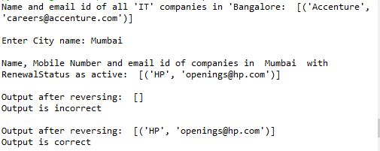

## Assignment 3

**Assignment Question:**

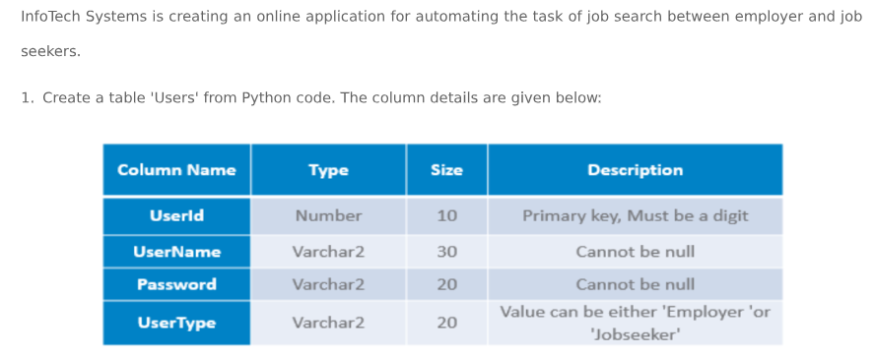

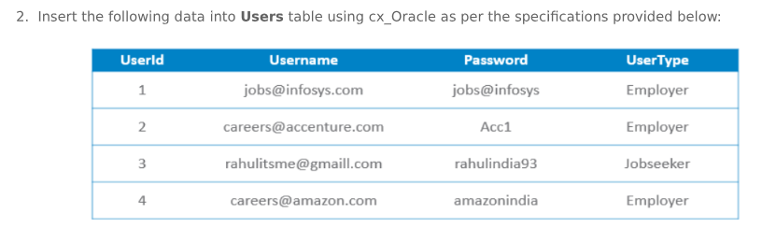

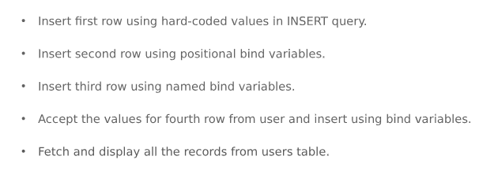

**Code:**

import cx_Oracle

from pprint import pprint

con = cx_Oracle.connect('SYSTEM', ‘sandy’, 'xe')

#print (con.version)

cur = con.cursor()

cur.execute("DROP TABLE Users")

cur.execute("""CREATE TABLE Users(

    UserId Number(10) PRIMARY KEY,

    UserName Varchar2(30) NOT NULL,

    Password Varchar2(20) NOT NULL,

    UserType Varchar2(25) CHECK (UserType IN('Employer','Jobseeker')))""")

cur.execute(

"INSERT INTO Users values (1,'jobs@infosys.com','jobs@infosys','Employer')")

cur.execute("INSERT INTO Users values (:p1,:p2,:p3,:p4)",

(2, 'careers@accenture.com', 'Acc1', 'Employer'))

cur.execute("INSERT INTO Users values (:p5,:p6,:p7,:p8)", {

'p5': 3, 'p6': 'rahulitsme@gmail.com', 'p7': 'rahulindia93', 'p8': 'Jobseeker'})

uid = int(input("Enter the User Id: "))

uname = input("Enter the User Name: ")

pw = input("Enter the Password: ")

utype = input("Enter the User Type: ")

cur.execute("INSERT INTO Users values (:p1,:p2,:p3,:p4)", {

'p1': uid, 'p2': uname, 'p3': pw, 'p4': utype})

cur.execute("SELECT * FROM Users")

print("ALL THE ROWS:")

for record in cur:

print(record, "\n")

**Output:**

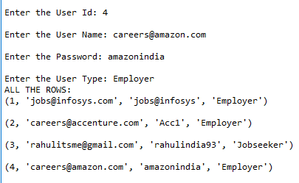

## Assignment 4

**Assignment Question:**

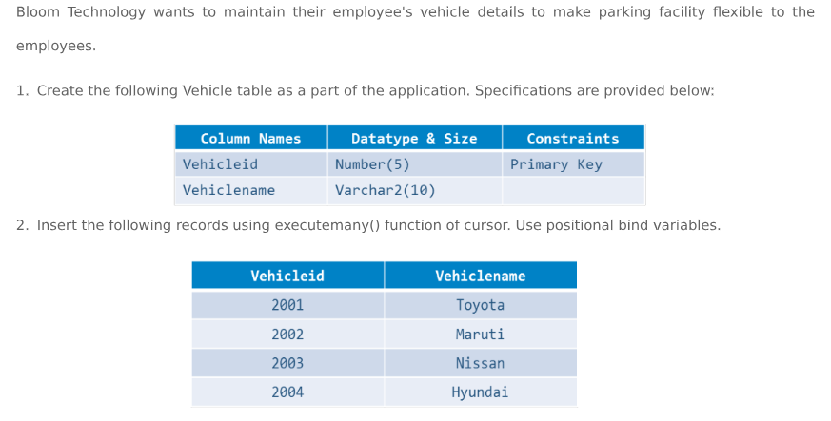

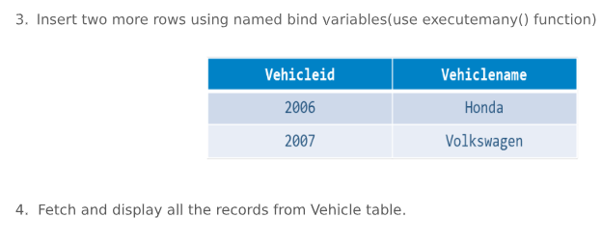

**Code:**

import cx_Oracle

con = cx_Oracle.connect('SYSTEM', ‘sandy’, 'xe')

#print (con.version)

cur = con.cursor()

cur.execute("DROP TABLE Vehicle")

cur.execute("""CREATE TABLE Vehicle(

    VehicleId Number(5) PRIMARY KEY,

    VehicleName Varchar2(10))""")

cur.executemany("INSERT INTO Vehicle VALUES(:p1,:p2)", [

(2001, 'Toyota'), (2002, 'Maruti'), (2003, 'Nissan'), (2004, 'Hyundai')])

cur.executemany("INSERT INTO Vehicle VALUES(:p3,:p4)", [

{'p3': 2006, 'p4': 'Honda'}, {'p3': 2007, 'p4': 'Volkswagen'}])

cur.execute("SELECT * FROM Vehicle")

print("ALL THE ROWS:")

for record in cur:

print(record, "\n")

**Output:**

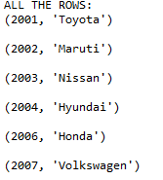

## Assignment 5

**Assignment Question:**

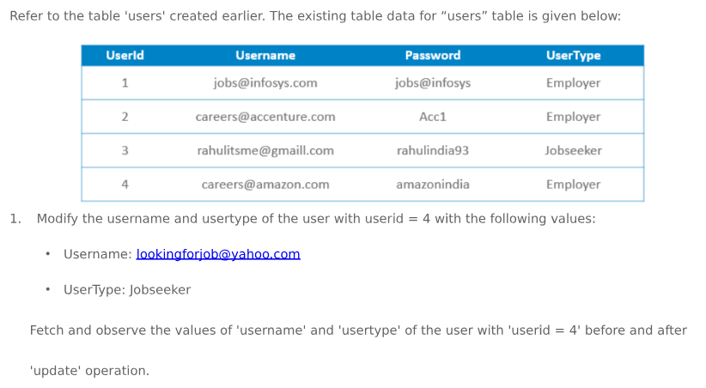

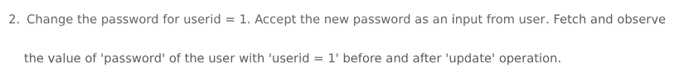

**Code:**

import cx_Oracle

con = cx_Oracle.connect('SYSTEM', ‘sandy’, 'xe')

#print (con.version)

cur = con.cursor()

cur.execute("DROP TABLE Users")

cur.execute("""CREATE TABLE Users(

    UserId Number(10) PRIMARY KEY,

    UserName Varchar2(30) NOT NULL,

    Password Varchar2(20) NOT NULL,

    UserType Varchar2(25) CHECK (UserType IN('Employer','Jobseeker')))""")

cur.execute(

"INSERT INTO Users values (1,'jobs@infosys.com','jobs@infosys','Employer')")

cur.execute(

"INSERT INTO Users values (2,'careers@accenture.com','Acc1','Employer')")

cur.execute(

"INSERT INTO Users values (3,'rahulitsme@gmail.com','rahulindia93','Jobseeker')")

cur.execute(

"INSERT INTO Users values (4,'careers@amazon.com','amazonindia','Employer')")

cur.execute("SELECT UserName,UserType FROM Users WHERE UserId=4")

print("Original UserName,UserType:")

for record in cur:

print(record, "\n")

cur.execute("UPDATE Users SET UserType='Jobseeker' WHERE UserId=4")

cur.execute("UPDATE Users SET UserName='lookingforjob@yahoo.com' WHERE UserId=4")

cur.execute("SELECT UserName,UserType FROM Users WHERE UserId=4")

print("Updated UserName,UserType:")

for record in cur:

print(record, "\n")

cur.execute("SELECT Password FROM Users WHERE UserId=1")

print("Original Password:")

for record in cur:

print(record, "\n")

newpass = input("Enter a new pasword: ")

cur.execute("UPDATE Users SET Password = :p1 WHERE UserId=1", {'p1': newpass})

cur.execute("SELECT Password FROM Users WHERE UserId=1")

print("Updated Password:")

for record in cur:

print(record, "\n")

**Output:**

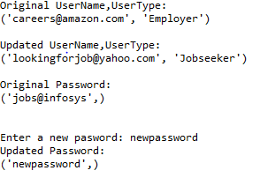

## Assignment 6

**Assignment Question:**

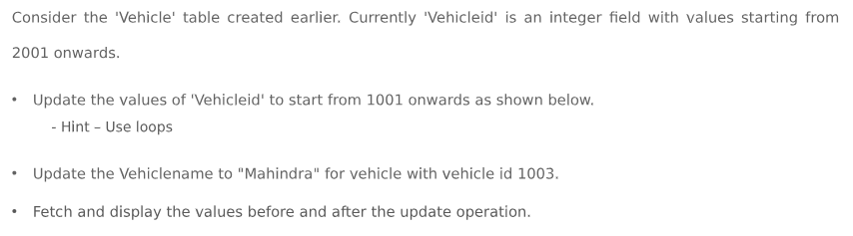

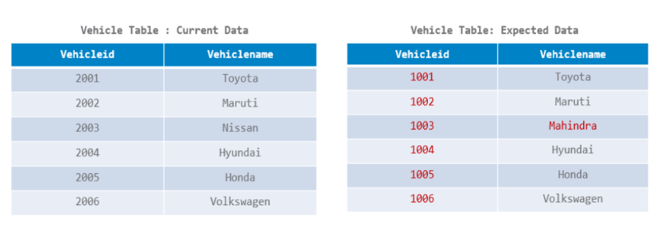

**Code:**

import cx_Oracle

con = cx_Oracle.connect('SYSTEM', ‘sandy’, 'xe')

#print (con.version)

cur = con.cursor()

cur.execute("DROP TABLE Vehicle")

cur.execute("""CREATE TABLE Vehicle(

    VehicleId Number(5) ,

    VehicleName Varchar2(10))""")

cur.executemany("INSERT INTO Vehicle VALUES(:p1,:p2)", [

(2001, 'Toyota'), (2002, 'Maruti'), (2003, 'Nissan'), (2004, 'Hyundai')])

cur.executemany("INSERT INTO Vehicle VALUES(:p3,:p4)", [

{'p3': 2005, 'p4': 'Honda'}, {'p3': 2006, 'p4': 'Volkswagen'}])

cur.execute("SELECT * FROM Vehicle")

print("Original Rows:")

for record in cur:

print(record, "\n")

oldval = 2001

newval = 1001

for i in range(cur.rowcount):

cur.execute("UPDATE Vehicle SET VehicleId = :param1 WHERE VehicleId =: param2", {

'param1': newval, 'param2': oldval})

# print(newval)

newval += 1

oldval += 1

cur.execute("SELECT * FROM Vehicle")

print("Updated Vehicle Ids:")

for record in cur:

print(record, "\n")

cur.execute("UPDATE Vehicle SET VehicleName='Mahindra' WHERE VehicleId = 1003")

cur.execute("SELECT * FROM Vehicle")

print("Updated Rows:")

for record in cur:

print(record, "\n")

**Output:**

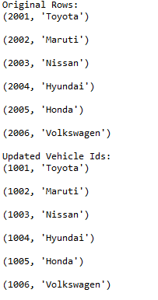

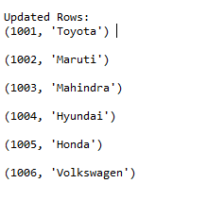

## Assignment 7

**Assignment Question:**

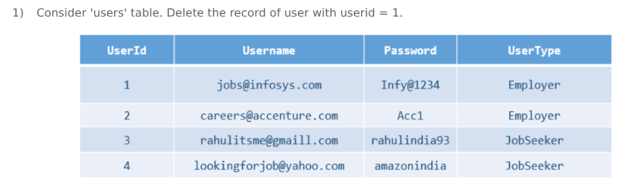

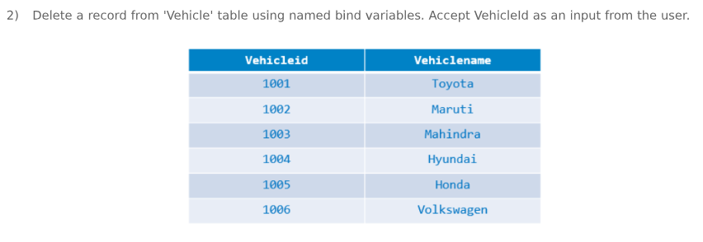

**Code:**

import cx_Oracle

con = cx_Oracle.connect('SYSTEM', ‘sandy’, 'xe')

#print (con.version)

cur = con.cursor()

cur.execute("DROP TABLE Users")

cur.execute("""CREATE TABLE Users(

    UserId Number(10) PRIMARY KEY,

    UserName Varchar2(30) NOT NULL,

    Password Varchar2(20) NOT NULL,

    UserType Varchar2(25) CHECK (UserType IN('Employer','Jobseeker')))""")

cur.execute(

"INSERT INTO Users values (1,'jobs@infosys.com','jobs@infosys','Employer')")

cur.execute(

"INSERT INTO Users values (2,'careers@accenture.com','Acc1','Employer')")

cur.execute(

"INSERT INTO Users values (3,'rahulitsme@gmail.com','rahulindia93','Jobseeker')")

cur.execute(

"INSERT INTO Users values (4,'careers@amazon.com','amazonindia','Employer')")

cur.execute("SELECT * FROM Users")

print("Original Rows:")

for record in cur:

print(record, "\n")

cur.execute("DELETE FROM Users WHERE UserId=1")

cur.execute("SELECT * FROM Users")

print("Updated Rows:")

for record in cur:

print(record, "\n")

cur.execute("DROP TABLE Vehicle")

cur.execute("""CREATE TABLE Vehicle(

    VehicleId Number(5) ,

    VehicleName Varchar2(10))""")

cur.executemany("INSERT INTO Vehicle VALUES(:p1,:p2)", [

(1001, 'Toyota'), (1002, 'Maruti'), (1003, 'Nissan'), (1004, 'Hyundai')])

cur.executemany("INSERT INTO Vehicle VALUES(:p3,:p4)", [

{'p3': 1005, 'p4': 'Honda'}, {'p3': 1006, 'p4': 'Volkswagen'}])

cur.execute("SELECT * FROM Vehicle")

print("Original Rows:")

for record in cur:

print(record, "\n")

vid = int(input("Enter Vehicle ID: "))

cur.execute("DELETE FROM Vehicle WHERE VehicleId=:param1", {'param1': vid})

cur.execute("SELECT * FROM Vehicle")

print("Updated Rows:")

for record in cur:

print(record, "\n")

**Output:**

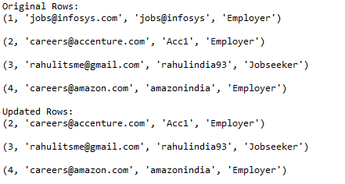

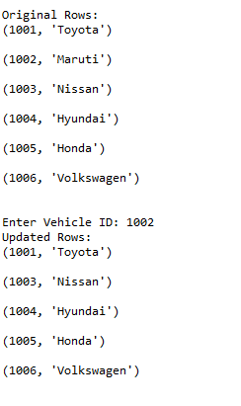

## Assignment 8

**Assignment Question:**

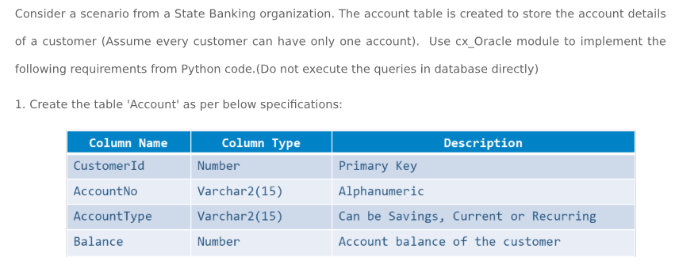

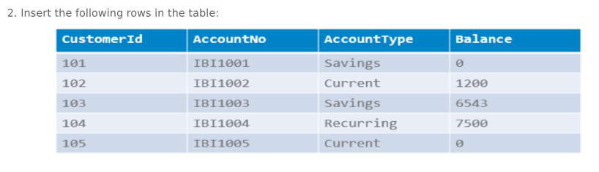

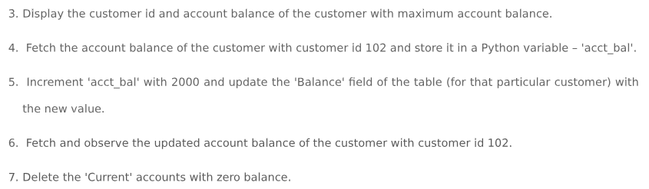

**Code:**

import cx_Oracle

con = cx_Oracle.connect('SYSTEM', 'sandy', 'xe')

#print (con.version)

cur = con.cursor()

cur.execute("DROP TABLE Account")

cur.execute("""CREATE TABLE Account(

    CustomerId Number(10) PRIMARY KEY,

    AccountNo Varchar2(15),

    AccountType Varchar2(15) CHECK (AccountType IN('Savings','Current','Recurring')),

    Balance Number(10))""")

cur.execute("INSERT INTO Account values (101,'IBI1001','Savings',0)")

cur.execute("INSERT INTO Account values (102,'IBI1002','Current',1200)")

cur.execute("INSERT INTO Account values (103,'IBI1003','Savings',6543)")

cur.execute("INSERT INTO Account values (104,'IBI1004','Recurring',7500)")

cur.execute("INSERT INTO Account values (105,'IBI1005','Current',0)")

cur.execute(

"SELECT CustomerId,Balance FROM Account WHERE Balance=( SELECT MAX(Balance) FROM Account )")

print(cur.fetchall())

cur.execute("SELECT Balance FROM Account WHERE CustomerId=102")

acct_bal = cur.fetchall()

for i in acct_bal:

for j in i:

acct_bal = j

print('Acct_Bal: ', acct_bal)

acct_bal += 2000

cur.execute("UPDATE Account SET Balance=: param1 WHERE CustomerId=102", {

'param1': acct_bal})

cur.execute("SELECT * FROM Account WHERE CustomerId=102")

print("Updated Rows:")

for record in cur:

print(record, "\n")

cur.execute("DELETE FROM Account WHERE Balance=0 AND AccountType='Current'")

cur.execute("SELECT * FROM Account")

print("Updated Rows:")

for record in cur:

print(record, "\n")

**Output:**

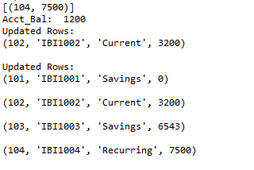

## Assignment 9

**Assignment Question:**

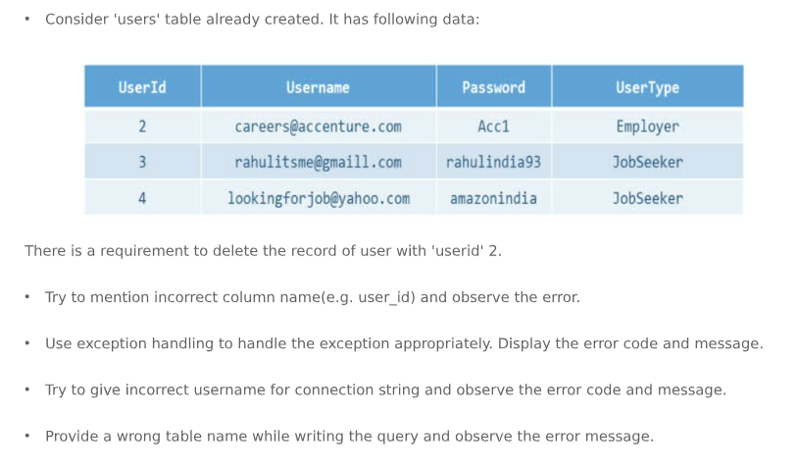

**Code:**

import cx_Oracle

con = cx_Oracle.connect('SYSTEM', 'sandy’, 'xe')

#print (con.version)

cur = con.cursor()

cur.execute("DROP TABLE Users")

cur.execute("""CREATE TABLE Users(

    UserId Number(10) PRIMARY KEY,

    UserName Varchar2(30) NOT NULL,

    Password Varchar2(20) NOT NULL,

    UserType Varchar2(25) CHECK (UserType IN('Employer','Jobseeker')))""")

cur.execute(

"INSERT INTO Users values (2,'careers@accenture.com','Acc1','Employer')")

cur.execute(

"INSERT INTO Users values (3,'rahulitsme@gmail.com','rahulindia93','Jobseeker')")

cur.execute(

"INSERT INTO Users values (4,'careers@amazon.com','amazonindia','Employer')")

try:

cur.execute("DELETE FROM Users WHERE User_Id=1")

except Exception as e:

error, = e.args

if error.code == (904):

print("Incorrect column name encountered")

con.close()

try:

con = cx_Oracle.connect('SYSTEM', 'sandymau', 'xe')

except Exception as e:

error, = e.args

if error.code == (1017):

print("Invalid username/password encountered")

try:

cur.execute("SELECT * FROM Cats")

print("Updated Rows:")

for record in cur:

print(record, "\n")

except Exception as e:

error, = e.args

print(e)

**Output:**

**C:\Users\Rumil\Desktop\unnamed (1).png**

**C:\Users\Rumil\Desktop\unnamed (2).png**

**C:\Users\Rumil\Desktop\unnamed (3).png**

## Assignment 10

**Assignment Question:**

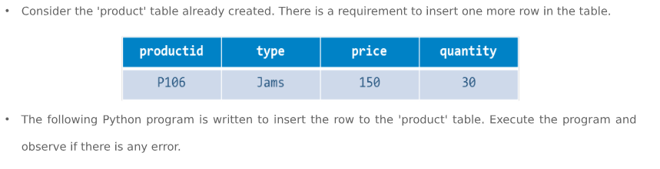

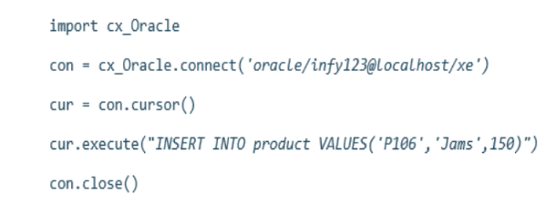



**Code:**

import cx_Oracle

con = cx_Oracle.connect('SYSTEM', 'sandy', 'xe')

#print (con.version)

cur = con.cursor()

try:

cur.execute("DROP TABLE product")

cur.execute('''CREATE TABLE product(productid VARCHAR2(10), type varchar2(15), price NUMBER, quantity NUMBER)''')

cur.execute('''INSERT INTO product VALUES('P101', 'Sweets', 1000, 10)''')

cur.execute('''INSERT INTO product VALUES('P102', 'Cereals', 500, 15)''')

cur.execute('''INSERT INTO product VALUES('P103', 'Vegetables', 300, 30)''')

cur.execute('''INSERT INTO product VALUES('P104', 'Fruits', 750, 25)''')

con.commit()

# cur.execute('''SELECT * FROM product''')

# print(cur.fetchall())

cur.execute("INSERT INTO product VALUES('P106','Jams',150)")

con.close()

except cx_Oracle.DatabaseError as e:

error, = e.args

if error.code == 947:

print('Query requires more values.')

**Output:**

Query requires more values.